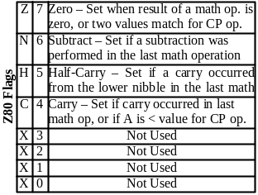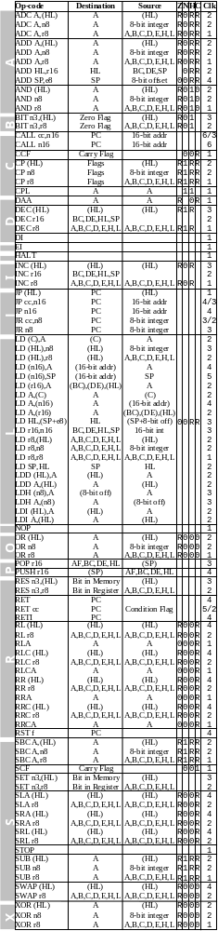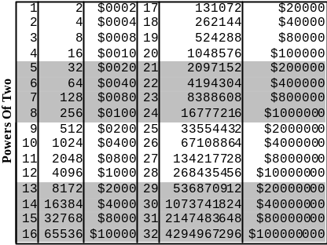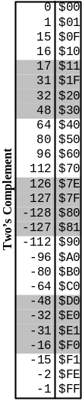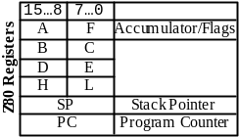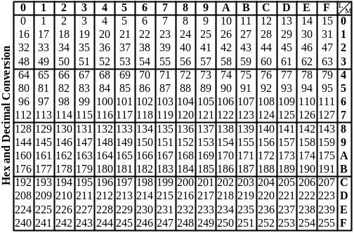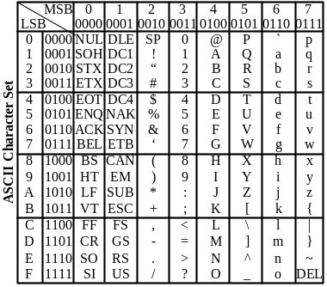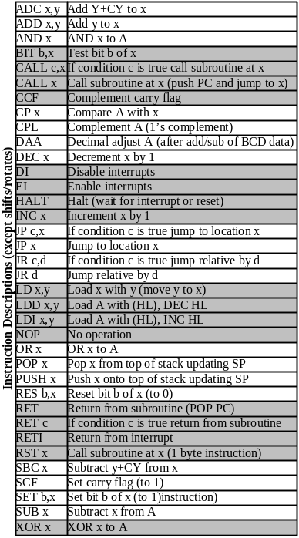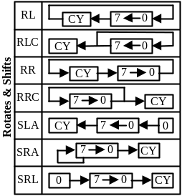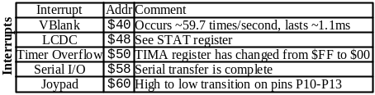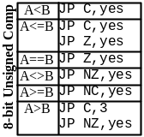

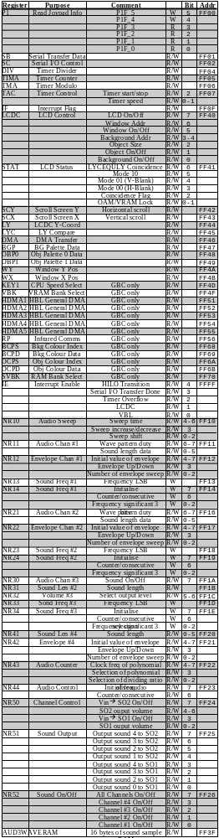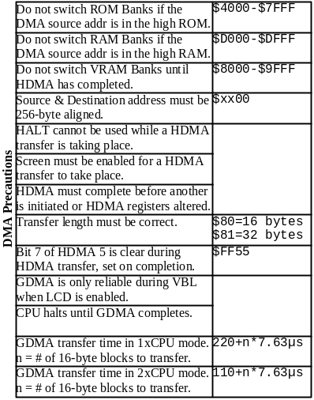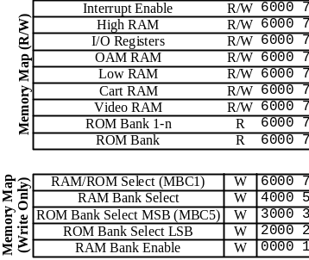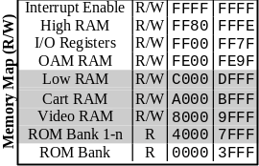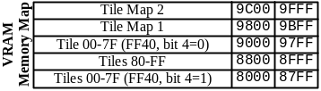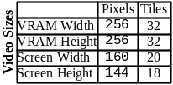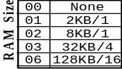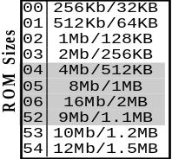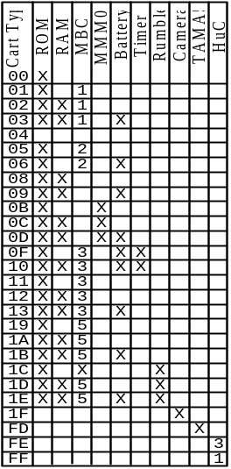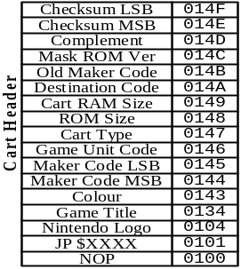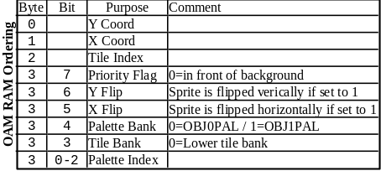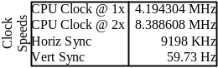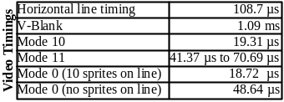
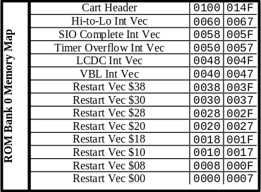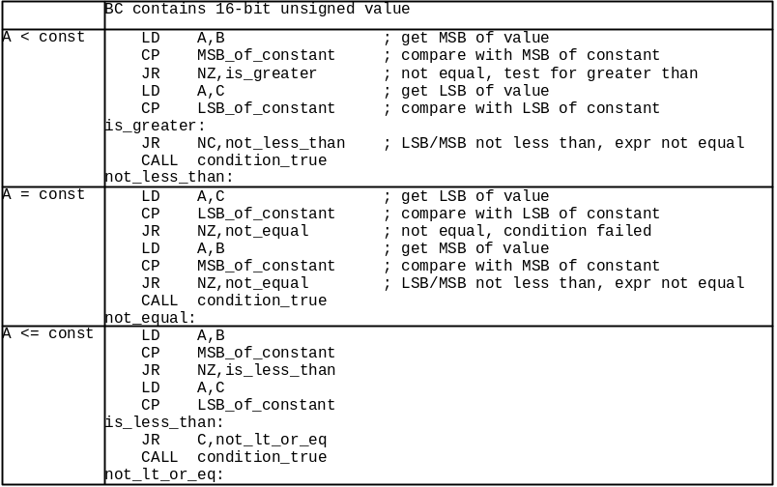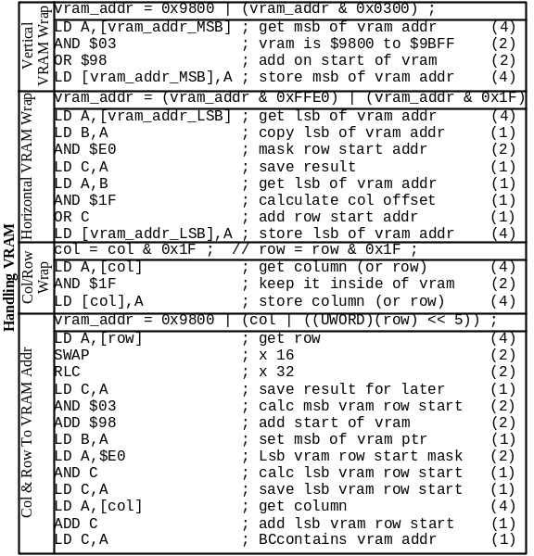

Gameboy Crib Sheet contains:
List of Z80 opcodes with timings, sizes, flags, registers, rotate & shift operations
Code for 8-bit unsigned compares
Two’s complement table
Powers of two table
Hex to Decimal/Decimal to Hex conversion table
ASCII character set
Gameboy interrupts
Complete list of all known Gameboy registers
Code for handling VRAM
Cartridge header information, including RAM Sizes, ROM sizes, MBC types
Video timings
Miscellaneous Gameboy timings
OAM RAM Ordering
Gameboy Memory Map
MB3 registers
MBC5 registers
Power consumption

Things to add:
Z80 code for 16-bit unsigned/signed compare operations
Z80 code for 8-bit signed compare operations
Palettes/Colours (RGB format)
Attribute v alues/bit fields for tiles
Sound tone tables
Meaning of GB/DMG/GBC flags at $143

Memory Bank Controller (MBC) 3 for GameBoy Information

Reg 0 - $0000-$1fff - RAM/clock write protect $0A - Enable $00 - Disable
Reg 1 - $2000-$3fff - ROM Bank Select $00-$7F - Rom bank #
Reg 2 - $4000-$5fff - RAM Bank/Clock Reg Select $00-$03 - RAM bank # $08-$0c - Clock register #
Reg 3 - $6000-$7fff - Latch clock counter data Writing $00 and then $01 latches clock data. Another write $00 and write $01 is required to latch data again.
Reg SEC - $08 - Seconds counter
Reg MIN - $09 - Minutes counter
Reg HRS - $0A - Hours counter
Reg DAYL- $0B - Lower 8 bits of day counter
Reg DAYH- $0C - bit 0 = Upper 1 bit of day counter bit 6 = start(0)/stop(1) clock counter bit 7 = Day counter carry bit
Notes: Bit 7 of Reg DAYH once set stays set until a 0 is written.
To access the clock counter the ram bank must first be turnedon by writing $0A to Reg 0.
To read the clock counter value, set Reg 3 to $01. This latchesthe values of all registers so they won't change on you while yourtrying to read them. However, this does not prevent the internalcounters from keeping correct time. If reg 3 is already set to$01 then write $00 and then $01.
For example, to read Reg SEC write $08 to Reg 2. The value ofReg SEC can then be read from any address in $A000-$BFFF range.Use a similar process for writing to a register.
Due to slow MBC3/clock interfacing, 4 machine cycles (16 clock cycles)are required between register accesses.
THe MBC3 is a memory controller for GameBoy that supportsROMs up to 16megabits (2megabytes) and RAM up to 256kbits(32kbytes). It has a built-in clock counter that requiresan external 32.768KHz crystal for operation.

Explanation of MBC-5 Registers
External Extended Memory Register (RAMG)
This register enables/disables access to external extended RAM. Access to external extended RAM is enabled by writing 0Ah in the RAMG register space from 000h to 1FFFh. If anything other than 0Ah is in this register, then read and write to RAM is disabled.
Lower ROM Bank Register (ROMB0)
This register sets the lower 8 bits of the 9-bit ROM bank register. The ROM bank can be changed by writing the desired ROM bank number in the ROMB0 register, which is the area from 2000h to 2FFFh.
Upper ROM Bank Register (ROMB1)
This register sets the upper 1 bit of the 9-bit ROM bank register. The ROM bank can be changed by writing the desired ROM bank number in the ROMB1 register, which is the area from 3000h to 3FFFh.
RAM Bank Register (RAMB)
This register sets the RAM bank register. The RAM bank can be changed by writing the desired RAM bank number in the RAMB register, which is the area from 4000h to 5FFFh.
Note: Bits that are crossed out are ignored by MBC-5, but please insert "0." The initial values are the values that are set automatically when the power is turned on and the system reset.

Undocumented features
Sprite bugs
Sound tone table

Cart Types
Value at $143 is $80 = GBC compatible game

Value at $143 is $C0 = GBC dedicated game
All other values at $143 indicate a regular GB game.

Verify cart header information table

What about ROM sizes above 16 MBit ?
07h 32 Mbit
08h 64 Mbit
Hmm. RAM sizes are written with Kbytes and number of banks and ROM size is
K/M Bit and K/M bytes... no number of banks here...should it not be shown
the same way..
The ram size does not comply with the one from Nintendo as far as I can see.
From Nintendo CGB User's Guide:
External RAM Size (0149H)
Store the code for the size of external RAM installed in the cartridge.
Address 149 RAM Size
00H No RAM or MBC2
01H -------
02H 64 KBit
03H 256 KBit
04H 1 Mbit
You write that 0146 is Game Unit Code: Nintendo says:
SGB Function Code (0146H)
Store the Function Code for the game program. Use the table below.
0146H Super Game Boy Function
00H Game Boy (will also run on Super Game Boy)
03H Uses Super Game Boy Functions
You forgot 0143 :) I think you used 142 instead...
CGB Compatibility Code (0143H)
Store the code which distinguishes between games that are CGB (Game Boy
Color) compatible, and those that are not.
Address 143H Denotation
00H CGB Incompatible
80H CGB Compatible
C0H CGB Exclusive
CGB Incompatible: A program which does not use CGB functions, but operates
with both CGB and DMG (Monochrome).
CGB Compatible: A program which uses CGB functions, and operates with both
CGB and DMG.
CGB Exclusive: A program which uses CGB functions, but will only operate
on a Game Boy Color unit (not on DMG/MGB). If a user attempts to play this
software on Game Boy, a screen must be displayed telling the user that the
game must be played on Game Boy Color.
Extra info from Nintendo's doc:
Game Code (013FH~0142H)
Please enter the 4 character Game Code in hexadecimal format which has
been assigned to your software title by NOA.
For example,
If the Game Code is "APCJ",
Address 013FH = 41H ('A')
Address 0140H = 50H ('P')
Address 0141H = 43H ('C')
Address 0142H = 4AH ('J')
This requirement only applies to new titles. If the program is changed and
a master ROM resubmitted for a game title which has already been marketed,
it is not necessary to insert a game code for this submission. (If the Game
Code is added to an existing game, please be aware of potential problems
with software verification routines in serial communication protocols or GB
Pak routines. For example, the Game Titles for the old version and the new
version MAY be different, causing the new version to be unrecognized by the
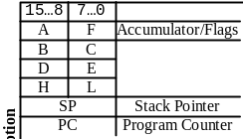software verification routine.)
Rumble Pak is not described

Power Consumption
Milliamps | Sound | No Halt | 2x Speed | IR Receive | IR Transmit
55
70 | Yes
58 |  | Yes
62 |  |  | Yes
57 |  |  |  | Yes
128 |  |  |  |  | Yes
74 | Yes | Yes
78 | Yes |  | Yes
83 | Yes | Yes | Yes
162 | Yes | Yes | Yes | Yes | Yes

